

**GRADE 8 Lesson 3- Arts**

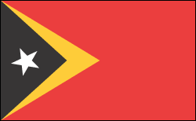

**Lesson:**Arts of the East Timor and Brunei

East Timor

According to the Constitution of the Democratic Republic of East Timor*, Part I, Section 15:*

"The [national flag](https://en.wikipedia.org/wiki/National_flag) is rectangular and is formed by two [isosceles](https://en.wikipedia.org/wiki/Isosceles) triangles, the bases of which are overlapping. One triangle is black and its height is equal to one-third of the length overlapped to the yellow triangle, whose height is equal to half the length of the Flag. In the centre of the black triangle there is a white star of five ends, meaning the light that guides. The white star has one of its ends turned towards the left side end of the flag. The remaining part of the flag is red

INTRODUCED THE HOUSING IN THE EAST

Housing in East Timor is one way of identifying its distinctive artistic tradition.

East Timor is one of the world's poorest nations. It has a jobless rate of 50 percent and about 42 percent of the population lives below the poverty line despite holding the rights to an estimated 8 trillion cubic feet of gas and 300 million barrels of light oil.

It is common for Timorese to keep huts of residences in caves in addition to their homes. Some have storage areas for grain, tobacco and beans and corals for their livestock. Many families spend heir weekends at their huts or caves.

After the violence that followed the vote of independence in August 1999, most people did not have houses and most of those that did had houses without roofs. Cities and towns had to be rebuilt from the ground up.

In a Dawan village in West Timor, one traveler posted on Escape Artistes: “The smoke from the open fire blows straight into Z’s face. He coughs. The family seem surprised. Smoke doesn’t bother the children here. They are kippered in it from birth. Outside their new hut, Kores’ wife smiles broadly

Bunak Houses

In east timor we have large conical designs. That is the **fataluku** houses, on the

on the other hand, are tall and elongated, and are stilt supports.

At The top the stilts are the main living room with a thatched roof.

This type of housing can be seen in some areas in the country, with a few houses

built only for display.

The traditional lopo and ume kebubu houses of the Dawan people, as well as the

circular houses and conical roofs of the Mambat people, are also seen in some

portions of East Timor.

Tais textile

Tais textile is mainly woven.

It showcases the fascinating ancient traditions of the East Timorese.

The textile has been crafted and used for several centuries.

The textile is designed with feathers and ornaments, and it is primarily used among the religious.

Some of the products made from tais are table runners, purses, bags and bookmarks.

Tais Mane

* It is made into traditional dresses called the tais mane for men which is wrapped around the man’s waist usually has a tassel finishing or the tais feto for the woman which is a tubelike, strapless dress.
* Another traditional dress is the selendang, which is a slender cloth worn around the neck.

Tais feto

Tais feto is for the women. It is a tubelike, strapless dress.

Salendang

Another traditional dress is the selendang, which is a slender cloth worn around the neck.

Tais Mane

* It is made into traditional dresses called the tais mane for men which is wrapped around the man’s waist usually has a tassel finishing

Tais feto

**Timor Leste clothing** comprises mostly the traditional clothing of the country which are made from home based textiles. The traditional textile of Timor Leste is known as Tais and they are being made in two styles which are called mane and feto. Mane **Tais** is the piece of **Timor Leste clothing** which is worn following the style of sarong around the waist of a person. Feto Tais is another piece of Timor Leste Clothing which is sewn into a long tube and the woman steps inside it and wears it like a dress.

The history of these two pieces of **Timor Leste clothing** goes back to the ancient times when it was bartered with livestock and gold and silver ornaments. The special significance of the Tais remains in the fact that some kinds of symbols and designs are painted on them. The history of East Timor is reflected in the designs and the cultural importance of the various places also comes out through them.

Traditional dresses’

Tais are made out of hand woven cotton and then various kinds of dyeing techniques are applied on it. Mostly East Timorese women involve themselves in the manufacturing of Tai and sometimes a piece of cloth can take more than a year to complete.

The **Timor Leste clothing** also has a connection with the **Portuguese** times and they were the first people to discard the traditional forms of clothing and bring in the modern styles into the market of **Timor Leste clothing**.

Likurai, Tebedai

Likurai- this is the traditional dress in East Timor . For a more meaningful dance, East Timor uses these dresses to dance and perform to welcome warriors who have returned home from battle. Another traditional dress is selendang

Tebedai dance

Traditional outfit for timorense to dance on independence day.

Tetun dance

It is performed to welcome warriors who have returned home

from battle. Another traditional dance is the **tebedai. Which is performed in East Timor.**

Basket Weaving

Apart from textile making, basket weaving is also important in East Timorese art. Basket weavers sell their crafts along the roads.

Pottery

Other than baskets, there are also pottery and wooden items that are also part of East Timor.

Brunei

Flag

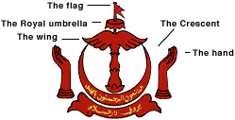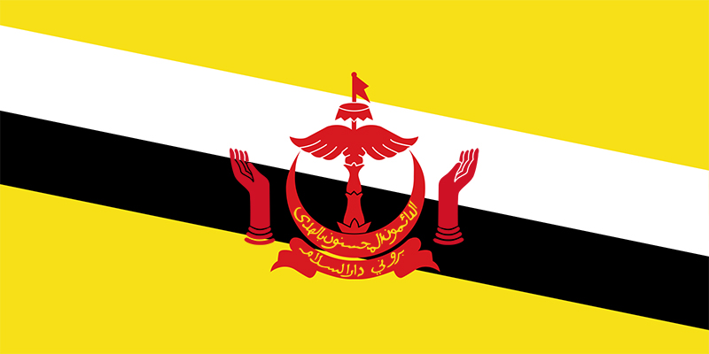

Meaning of the Flag

The yellow background of the Brunei represents the Sultan of Brunei

The black and white stripes of the Brunei flag represents the country's chief ministers.

The emblem of the Brunei is called the Brunei’s coat of arms it contains five components

The flag, royal umbrella,wing hands and the crescent symbol of islam

The script of the emblem is written in arabic and means always in service with Gods guidance.

**Art in Brunei has influences from its neighboring countries.**

Brunei handicrafts include silverwork, brasswork, weaving, kris making, songkok ( Malay-style cap) making and tudung dulang or the traditional food covering weaved from nipa leaves.

Borneo was mainly occupied by the Kenyah and Kayan civilizations;

Animals were important themes in the Kenyah and Kayan arts Also, art is something that both genders in Brunei value.

The Scary Masks

These are masks with scary faces and ferocious expressions that are made by men. These masks are used to protect their rice field.

These masks are believed to ward off spirits that can cause damage to crops. Also, some masks that serve to catch the soul are also made because people of Brunei believe that when people are asleep or unconscious, their souls can escape from their physical bodies. To counter this, a soul catching mask may be used, or a shaman may be sent to catch the escaped soul.

Bead work in Brunei

**Bead work** is a complex art. The beads are used to decorate clothing, hats, and other items such as the a ba which is a traditional baby carrier.

Seed beads are used for designs. At some point in Brunei commerce, beads were used for trade.

These materials are also believed to have powers, and thus they are often used as amulets.

Metal

**Metal is an important material in Brunei traditional art.**

Brunei is known for its brass work for its traditional crafts. Artists make cannons that have intricate designs.

There are also household materials that are made of brass and silver.

Despite being highly regarded by the Sultans of Brunei, brasswork and silverwork have also declined with the downfall of the sultanate.